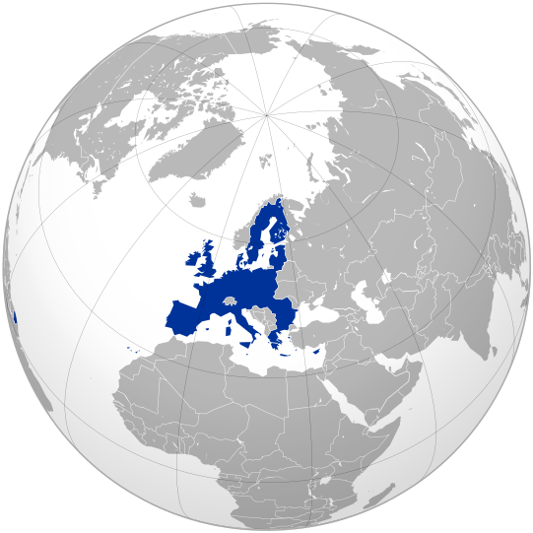

FeelingEUROPE Foundation

Desk for European values and affairs

Mental Relief can govern Financial Markets! (*)

With the EMU, Europe implemented the euro. However, it appeared that it became only a monetary and not economic Union, for a coordinated and concerted trade and economic policy, aimed by common European organizations, did not appear.

Now, and almost a decade, Greece’s government budget is out of order. Public debt slipped too largely through the ceiling, by which Europe is walking along the edge (again). The continent can only hope that she is strong enough to overcome this crisis.

Greece’s current account needs to be balanced and a basic equilibrium for capital account should be exposed. Only in presence of necessary conditions, such as time, timing and capability, these aimed results can be achieved.

To let the deficit decrease, far-reaching measures have to be followed out. On the one side by austerity (lower labour costs, lower prices, a severe tax policy and dispose of assets) and on the other hand by expansion of foreign trade and investments (energy, digital agenda). Bureaucracy needs to be removed and measures have to be taken by which capital can be raised.
Results from this will show positive signs and will increase the chance to reverse the present situation.

14 And 15 June I participated the Greek Power Summit in Athens. Greece does not want to be deserted. On the contrary, the country is seeking and following many ways to emerge from the crisis and not only through money. Also useful knowledge and assistence in a wide range of scopes from societal life are at stake. For example I experienced discussions on how to build institutions and how to establish think tanks to be able to facilitate and to achieve aims.

Against this, Europe tries to manage the debt burden smoothly, in order to avoid heavily infection to government budgets of other EU-member states and is reforming the EMU.

The European Union, established to advance prosperity and well-being for the citizens of Europe, is equipped with high qualified expertise and with necessary organizations to facilitate policies and missions. The European Commission’s Directorates Justice and Home Affairs ensures that all activities necessary and beneficial to the economic, cultural and social growth of the EU may develop in a stable, lawful and secure environment.
Concerning goals and required assistence by Greece, I propose to establish a particular EU-desk in Athens in order to be able to be ready to oblige and support policies from society as a whole (politicians, business, industry and citizens).

European civilization is a synthesis of the Greek, the Roman and the Christian spirit: the Greek spirit contributed the ideas of freedom, truth and beauty, the Roman those of the state and the law, and the Christian those of faith and love.

Let us preserve our civilization. About 60 years ago, great leaders paved the way for an united Europe during circumstances, which were much more worse than they are now and they succeeded.

Your sincerely,
E. (Erik) van der Kooij
Director FeelingEUROPE Foundation
member Jean Monnet Centre of Excellence
website: www.feelingeurope.eu
email : contribute@feelingeurope.eu
(*) Some three years ago I noticed the letter 19 May 2008 on ‘Financial Markets can not govern us!’ (see
attachment). This letter made severe issues clear and did provide recommendations.
FeelingEUROPE fosters and guides European values and affairs to achieve more understanding and involvement with the aim to advance prosperity and wellbeing. For that purpose the desk promotes (knowledge about) European values and affairs, takes position as nexus between citizens, institutions, Europe, her identity and everything that is related in wider sense, mainly concerning cultural, philosophical and political fields. But also economical and technical fields are at stake. Furthermore, the desk does research work, delivers resonance and keeps up a website.
The foundation is an exponent from the conferences 'Europe, a Beautiful Idea' (5th) and 'The Sound of Europe'.
FeelingEUROPE Foundation, established at Wassenaar 5-12-2007, Commercial Register The Hague number 27308610.

